**SOFTWARE TESTING ASSIGNMENT 1**

Module 1 [Fundamental]

* What is SDLC

Software Development Life Cycle [SDLC] is the gradually approach to develop a software within appropriate cost, good quality and proper time frame.

* What is software testing?

Software testing is process used to identify the correctness, completeness end quality of developed computer software.

* What is Agile Methodology?

It is a way of developing software that adapts to changing requirements and feedback.

* What is SRS?

Software requirement specification [SRS] is a detailed description of a software system to be developed with its functional or non-functional requirements.

* What is OOPS?

Object oriented programming is a programming model that use ‘OBJECT’ to design application and computer programs. Here it is referred as functional testing or black box testing.

* Write basic concept of OOPS.

OOPs basic concept is referring to languages that use object in programming, its used to structure the software program in to simple reusable code.

There are some basic concepts like class, object, abstraction, polymorphism, encapsulation, inheritance.

* What is object?

An object is the basic unit of OOP, which is accessed by its properties called data member and member function. It creates the memory for the class.

* What is class?

Class is a detailed description, the definition and the templates of what an object will be. it is the blueprint of any object.

* What is encapsulation?

A wrapping up of data and functions in to a single unit is called encapsulation. It is a protective shield that prevents data from being accessed by the code outside this shield. What is inheritance?

One class (Super, Base) inherits the properties of another class (Sub, Derived).

Types of Inheritance:

Single Inheritance

Multilevel Inheritance

Hierarchical Inheritance

Hybrid Inheritance

Multiple Inheritance

* What is polymorphism?

An ability to take one name having many different forms.

Compile time Polymorphism: (Operator Overloading) Method name should be same in single class but its behaviour (Arguments & Data type) is different.

Run time Polymorphism (Operator Overriding) Method should be same in super class and sub class but its behaviour is different.

* Draw the use case of online book shopping.

* Draw the use case of online bill payment system.

* Write SDLC phases with basic introduction.

There are six phase of software development

1. Planning and requirement gathering:

In this phase involves planning and gathering information for the software. like clarity, requirement, amalgamation, and functionality.

1. Analysis:

Software required specification [SRS] like detailed description. For example, its required customer requirements, Functional requirements, Non-functional requirement.

1. Design:

It shows graphical representation of the system by DFD [data flow chart], E-R Diagram, Use case, Flow chart.

1. Implementation:

After the design it’s time to apply in code, in several iterations this phase is also called Development. This is the longest phase in SDLC.

1. Testing:

In this Phase software entirely tested to ensure that it’s close to requirement, correctness and quality.

1. Maintenance:

This phase includes identify and repair errors, provide good service after sale and software upgradation.

* Explain Phases of the waterfall model.

The Waterfall model is a classical software lifecycle that works software development as in step-by-step. First of all, gather the requirement- analyse the data- implementation[coding] – deployed and maintenance, this “waterfall” pattern between the various development phases.”

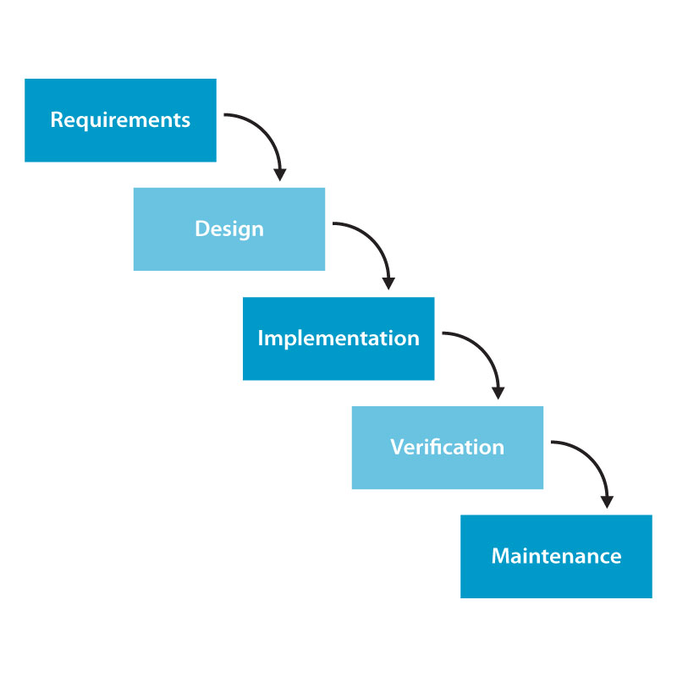

Waterfall model diagram

* Write the phase of spiral model.

“Spiral Model is very widely used in the software industry as it is in synch with the natural development process of any product learning with maturity also involves minimum risk for the customer as well as the development firms.”

It is working in four phases:

A. Planning / Requirement Gathering / Feasibility Study

B. Risk Analysis / Design

C. Engineering / Coding

D. Customer Evaluation / Testing

Bohem’s Spiral Model

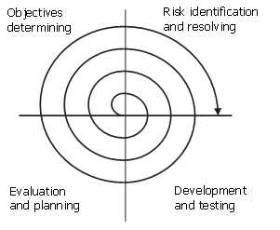

* Write agile manifesto principles

“Agile SDLC model is a combination of iterative and incremental process models with focus on process adaptability and customer satisfaction by rapid delivery of working software product.” Its working on four principles:

Agile Manifesto Principles / 4 Values of Agile Manifesto

1. Individuals and interactions over processes and tools
2. Working software over comprehensive documentation
3. Customer collaboration over contract negotiation
4. Responding to change over following a plan.

* Explain working methodology of agile model and also write pros and cons.

Pros:

1. Very realistic approach

2. Rapid delivery.

3. Functionality can be developed rapidly

4. Resource requirements are minimum.

5. Little or no planning required

6. Promotes teamwork and cross training.

7. Suitable for fixed or changing requirements

8. Gives flexibility to developers

Cons:

1. More risk of sustainability, maintainability and extensibility.

2. Depends heavily on customer interactions.

3. Very high individual dependency.

4. Minimum documentation generated.

5. Not useful for small projects.

6. Not suitable for handling complex dependencies.

* Draw use case of payment gateway.

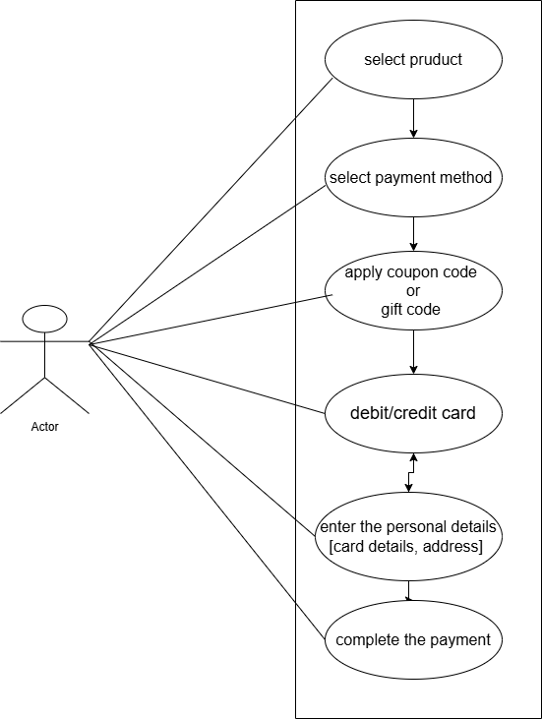

* Draw use case of product using COD

* What is seven key principles of software tasting? Explain in details.

Software Testing is working on key concepts and methodologies to enhance quality product. From test planning to execution and analysis, understanding these principles.

1. **Testing shows the presence of Defects**.

Software testing reduce the presence of defect but it can not prove that software is defect free. Even multiple tests can not sure that software is 100% bug free.

2**. Exhaustive Testing is Impossible**.

In this process functionality of the software has all possible input [valid or invalid] and precondition is known as exhaustive testing. It can test only some test case and assume that the software is correct and it will produce the correct output in every test case then it will take more time, cost and effort with is impossible.

3. **Early Testing**

Early testing phase is the less expensive in SDLC. For better performance of software, testing will start at the early phase i.e. testing will perform at the requirement analysis phase.

4. **Defect Clustering**

A small number of modules contain most of the defects discovered during pre-release testing or are responsible for the most operational failure.

5. **The Pesticide Paradox**

Repeating the same test case again and again will not find new bug. So, it is necessary to review the test cases and add or update test cases to find new bug.

1. **Testing is Context Dependent**.

The testing approach depends on the context of the software developed. Different types of software need to perform different types of testing. For example, the testing of the e-commerce site is different from the testing of the Android application.

1. **Absence of Error Fallacy**.

If a built software is bug-free but does not follow the user requirement then it is unusable. It is not only necessary that software is non defect but it is also mandatory to fulfil all requirements.

* Difference between verification and validation

|  |  |
| --- | --- |
| Verification | Validation |
| Verification is a process which is performed at development level. | Validation is a process which is performed at testing level. |
| Verification activities are Reviews and Inspections. | Validation activities are testing. |
| It is the process of evaluating product of development to check whether the specified  requirements meet or not. | It is the process of evaluating the product of development to check whether it satisfied  business requirement or not. |
| The evaluation of verification can be achieved by planning, Requirement specification, Design Specification, Code specification, and test cases. | The evaluation of validation can be achieved as an actual product. |
| Verification is the static testing | Validation is the dynamic testing |